**5.4 Snippet Generator**

This section will guide you to:

* Generate a step snippet with the Snippet Generator

**Please Note**: This demo is incremental. Ensure you have completed the earlier demos.

This lab has one sub-section, namely:

5.4.1 Generating Pipeline code with Snippet Generator

**Step 5.4.1:** Generating Pipeline code with Snippet Generator

* Navigate to the Pipeline Syntax link (referenced below) from a configured Pipeline, or at ${YOUR_JENKINS_URL}/pipeline-syntax.

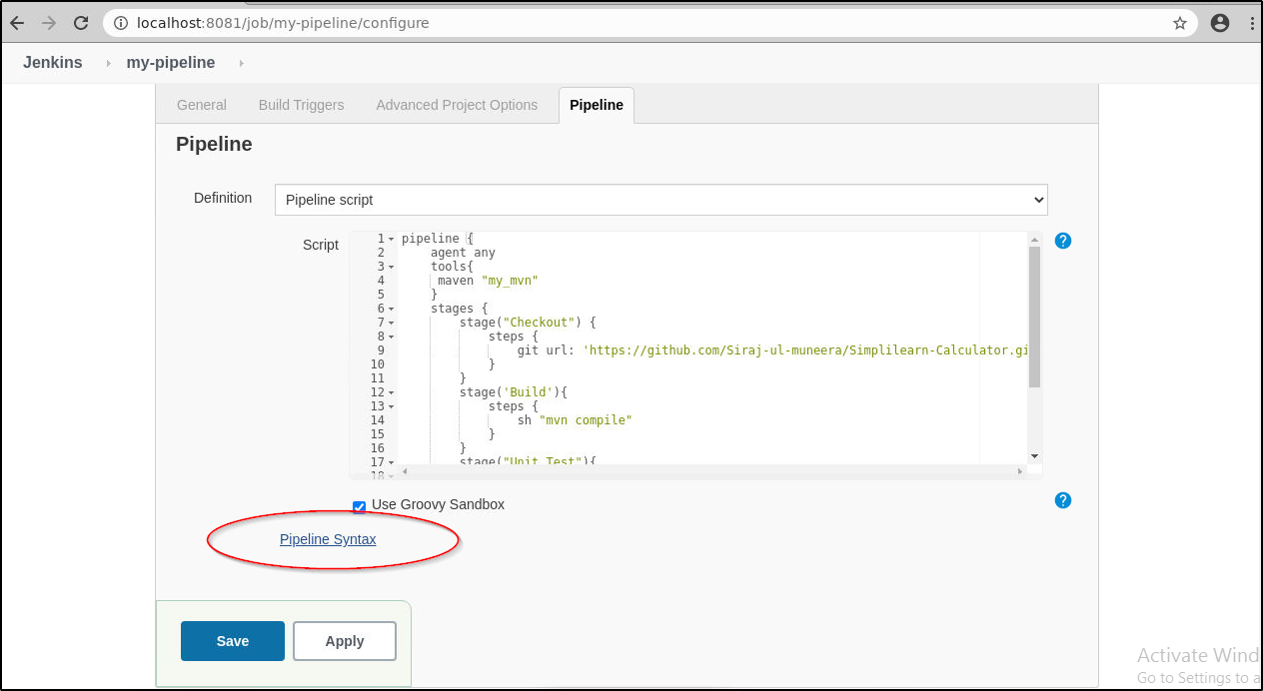

* Select the desired step in the Sample Step dropdown menu

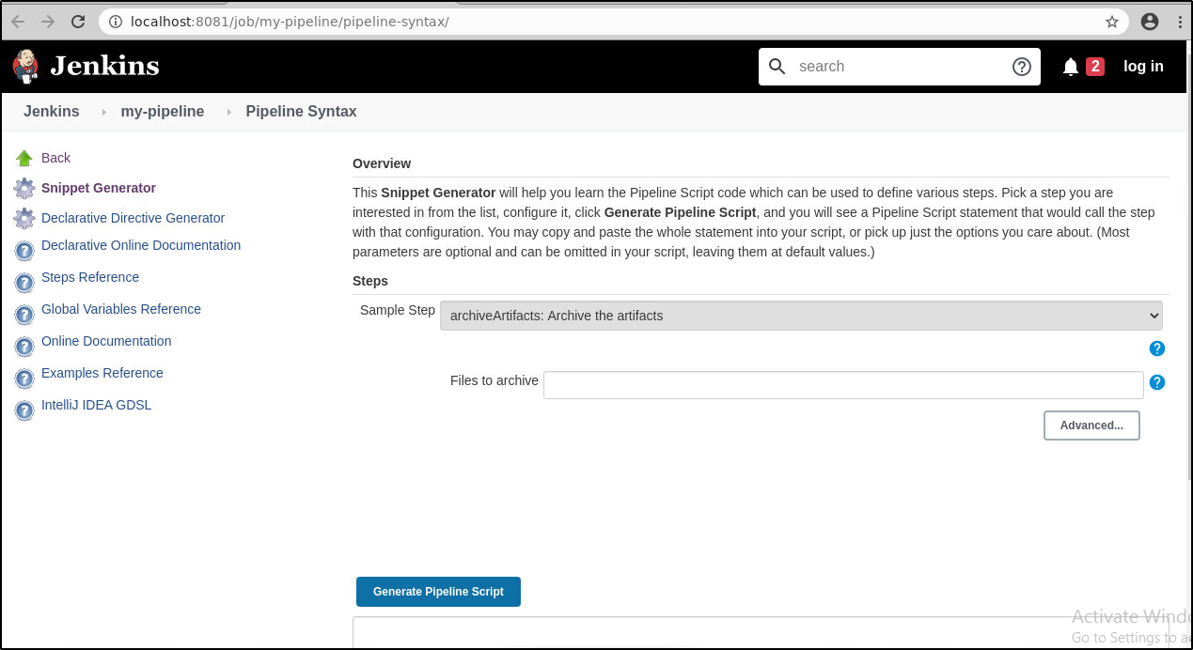

* Use the dynamically populated area below the Sample Step dropdown to configure the selected step.
* Click Generate Pipeline Script to create a snippet of Pipeline which can be copied and pasted into a Pipeline.

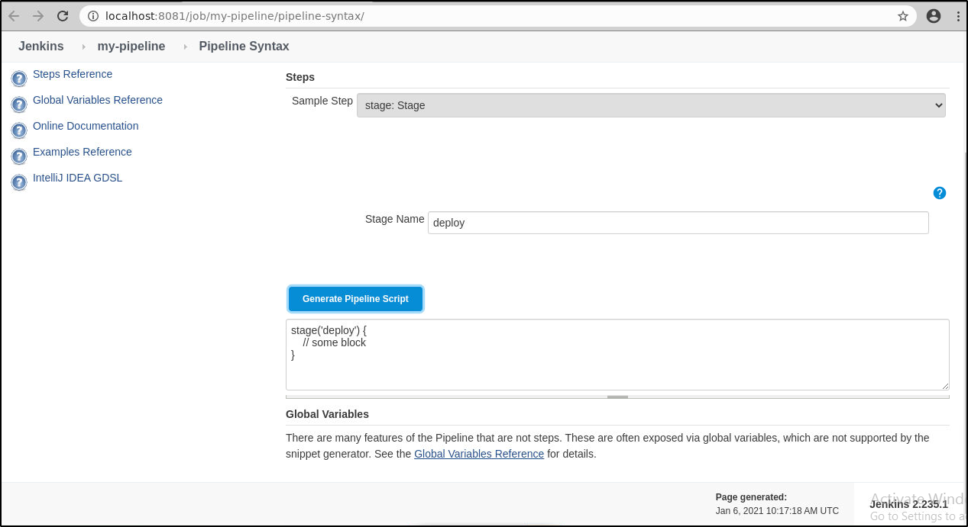

* To access additional information and/or documentation about the step selected, click on the help icon (question mark icon in blue).